**Student Name:** Aakash Thapliyal  **UID:** 24MCC20027

**Branch:** MCA(ccd) **Section/Group:** A 1

**Semester:** 1st  **Date of Performance:** 06-11-2024

**Subject Name:** ADBMS  **Subject Code:** 24CAP-607

**1. Title of Project.** Registration form using HTML,PHP and SQL

**2. Aim/Overview of the practical:** This project aims to create a simple registration form using HTML for the frontend, PHP for server-side processing, and MySQL for database management. The registration form allows users to enter their personal details, which are then stored in a MySQL database using XAMPP as the server environment.

#### **3**. Technologies Used

* **Frontend:** HTML, CSS (for styling)
* **Backend:** PHP
* **Database:** MySQL

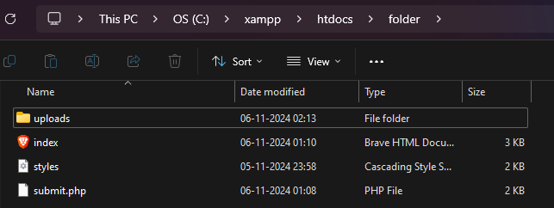

* **Server:** XAMPP (Apache, MySQL)

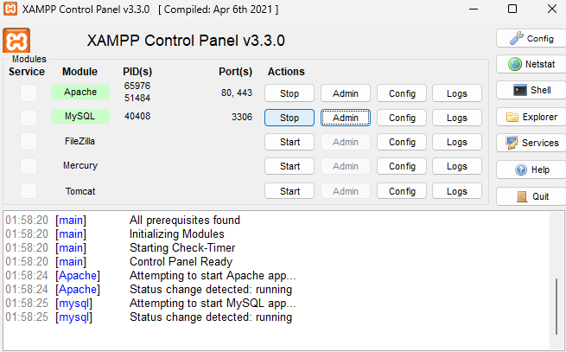

#### Database Setup

**Install XAMPP:** Download and install XAMPP from Apache Friends. Start the Apache and MySQL services using the XAMPP Control Panel.

**Create a Database:**

* Open phpMyAdmin by navigating to http://localhost/phpmyadmin in your web browser.
* Create a new database called registration_db.
* Run the following SQL query to create a users table:

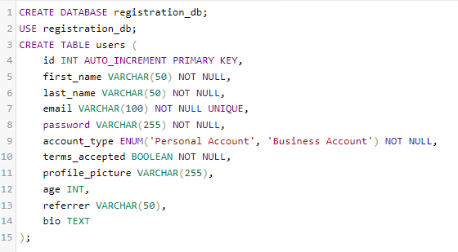

1. **Database in mysql:**

* Now database and table is created which we can observe in GUI.
* In table users we have created columns which is also visible on pannel and we can explore it by just clicking on it.

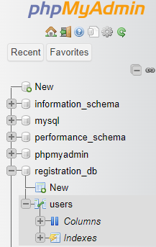

(GUI of Database)

1. **Inserting Entries in database using Structure query language:**

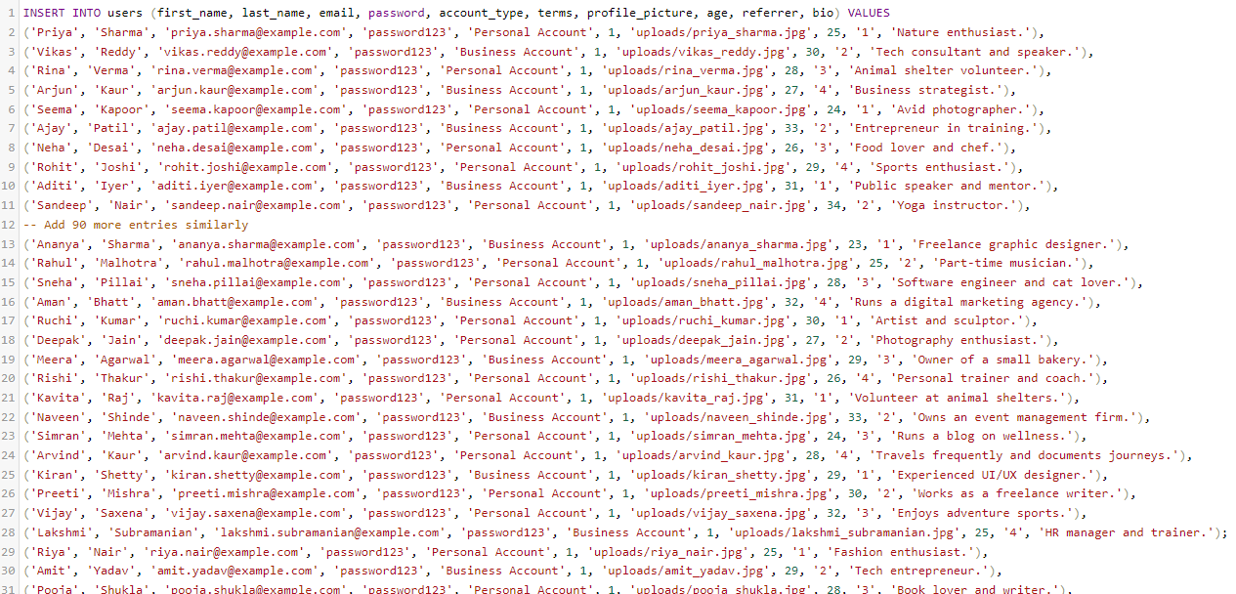

#### 5. HTML Registration Form

Create a file named registration.html in the htdocs directory of your XAMPP installation:

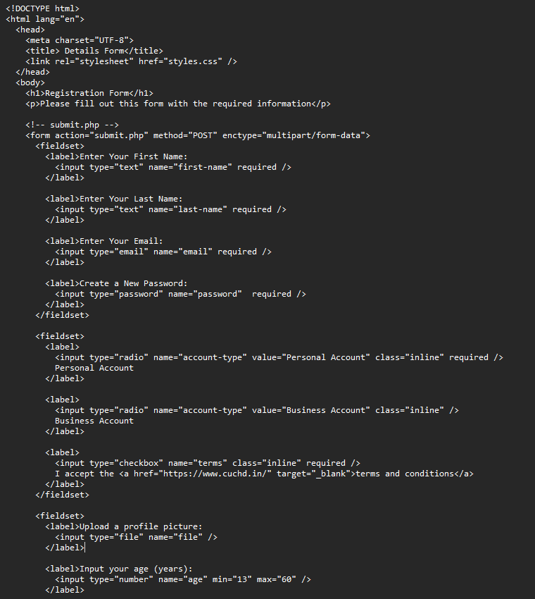

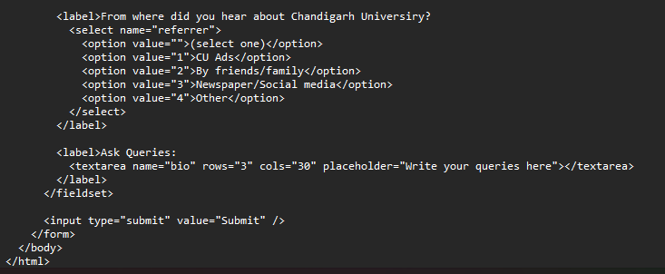

#### 6. PHP Script for Processing Registration

Create a file named register.php in the same directory:

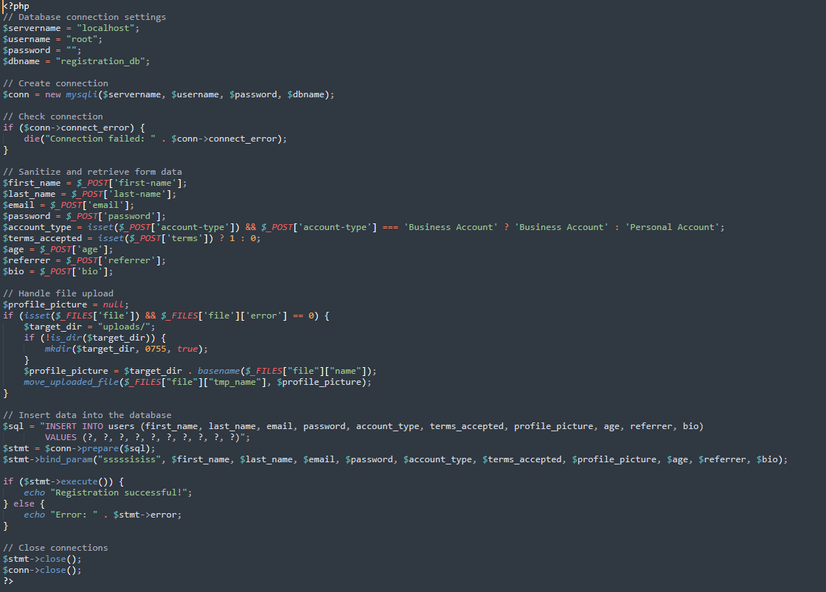

1. **HTML Registration form:**

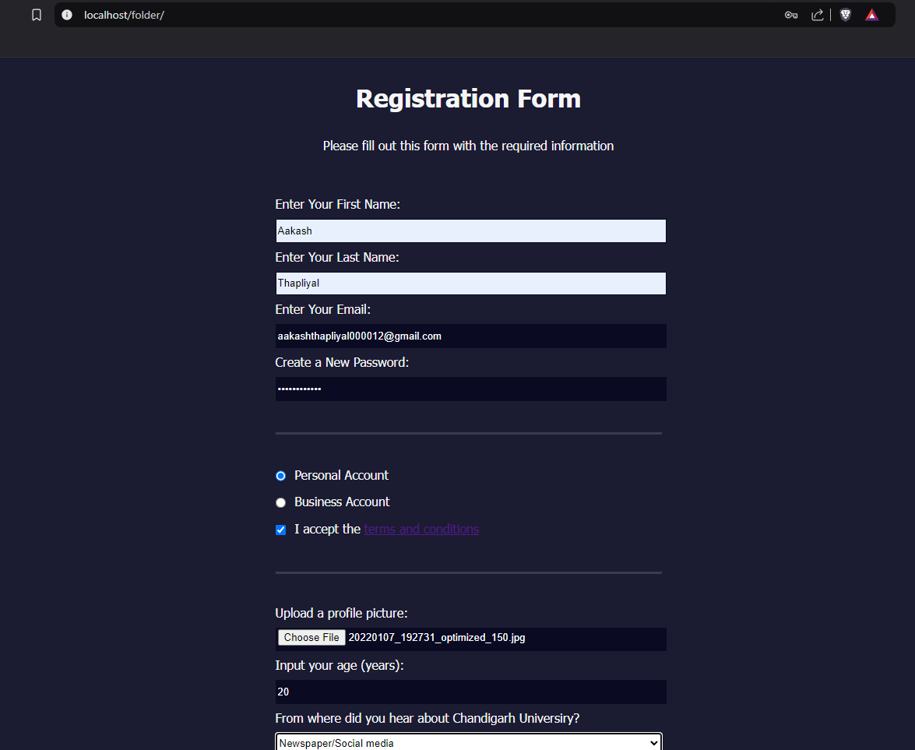

1. **Acknowledgment after submission:**

This screen willt only show when data is submitted successfully to the database.

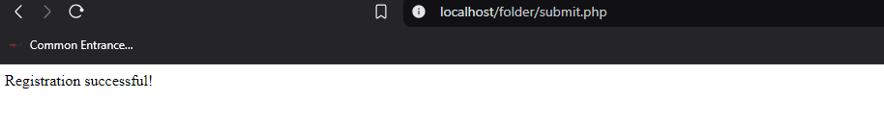

1. **Final database with data:**

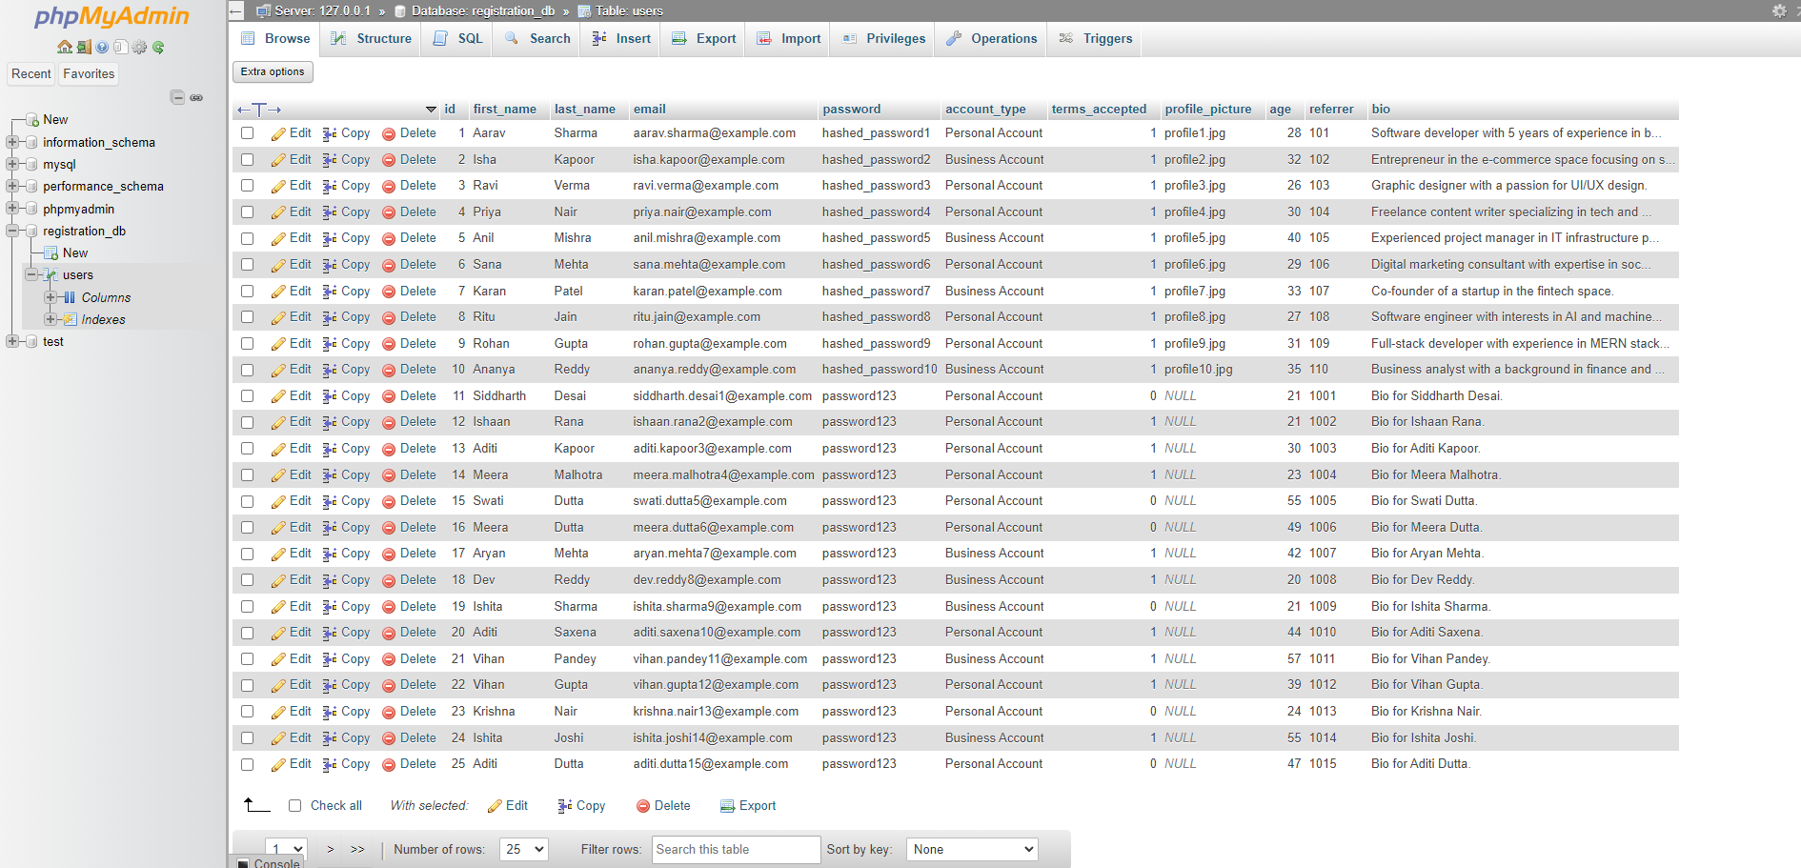

1. **Searching using SQL query**

This query will searcch all the users whose age is greater then 30.



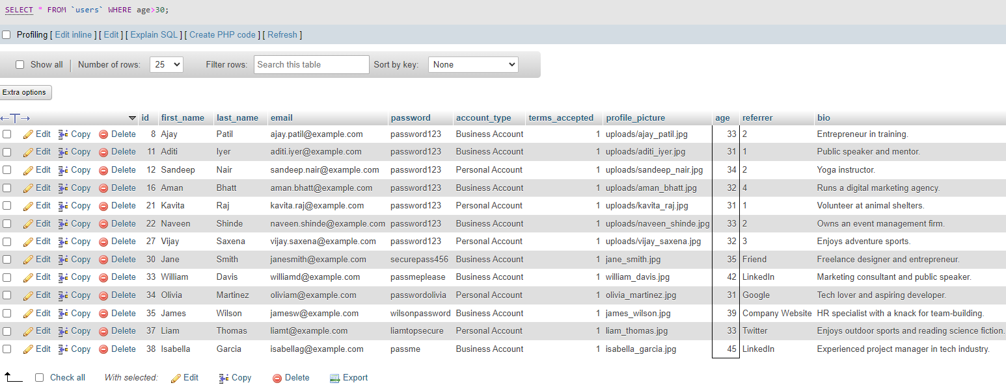

#### Testing the Application

1. Open your web browser and navigate to http://localhost/registration.html.
2. Fill in the registration form and submit it.
3. Upon successful submission, you should see a success message, and the data will be stored in the users table of your registration_db database.

#### Conclusion

This project demonstrates a simple registration form using HTML, PHP, and MySQL. It provides a foundational understanding of how to handle form submissions and interact with a database. Further enhancements could include validation, error handling, and more complex user management features.

### 13. Future Work

* Implement user input validation and error handling.
* Add features for user login and session management.
* Improve UI/UX with advanced front-end frameworks.

1. **Learning outcomes (What I have learnt):**

**Understanding Form Handling**: Learners will understand how to create and handle user input through HTML forms and process it using PHP on the server side.

**Database Connectivity**: Learners will gain knowledge of connecting PHP scripts to MySQL databases, performing basic operations like inserting data into tables.

**Security Practices**: Learners will be introduced to basic security practices, such as password hashing using PHP, to ensure user data protection.